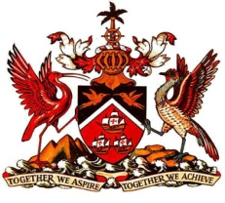

PERMANENT MISSION OF THE REPUBLIC OF TRINIDAD AND TOBAGO
TO THE OFFICE OF THE UNITED NATIONS, GENEVA

Statement at the Universal Periodic Review (UPR) of Suriname, Palais des Nations, Geneva, 2nd May 2016

Thank you Mr. President.

Trinidad and Tobago wishes to express its appreciation to Suriname for the presentation of its detailed national report for its second cycle review.

My delegation commends efforts to promote gender equality and empowerment of women and to conduct awareness-raising activities and training in relation to gender-based violence and gender-mainstreaming. Such efforts have certainly borne fruit as exemplified by the amendment to the Act on the Regulation of the Surinamese Nationality and Residency in 2014 and the increased political participation of women.

The formulation of a social system to address poverty and social protection through the adoption and implementation of legislation related to minimum wage, pension benefits and basic health insurance is certainly noteworthy.

My delegation recommends that Suriname:
- ensures that juveniles in detention are housed in separate facilities from adults;
- increase efforts to improve access to education in rural areas; and
- take steps to ensure that the access of persons with disabilities to education is not limited to vocational fields but covers wider educational areas.

Trinidad and Tobago extends its very best wishes to Suriname, our CARICOM partner, for a successful review.

I thank you Mr. President.

